CitiBike Analysis Spring Months (Mar-May) Years (2016-2018)

Phenomenon 1:

Male riders completed more trips compared to Female riders during the spring months. Due to erroneous data as it relates to a high probability of mis keyed information, I did not include anyone born prior to 1940. With this information while taking into account the possibility of incorrect information being plausible, it appears that female riders have shown to take longer trips compared to Male riders.

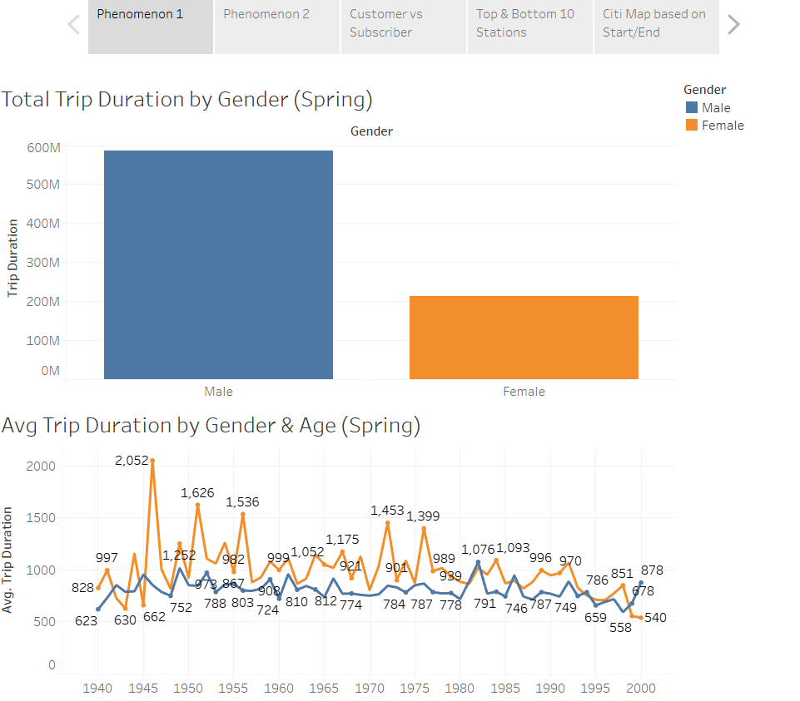

Phenomenon 2:

Based on the number of trips completed by the most popular Bike ID’s the most popular ID’s will more than likely need service soon and/or more often. Based on the comparison of the datasets chosen the most popular times in the spring in the early hours are between 8am and 9am. The evening hours are between 5p and 7p. The evening hours would probably coincide with favorable peak temperatures in the early evening hours. Lengthy Trips tend to occur 1p-6p. 3am also appeared to be a popular time for lengthy bike rides which was an interesting find.

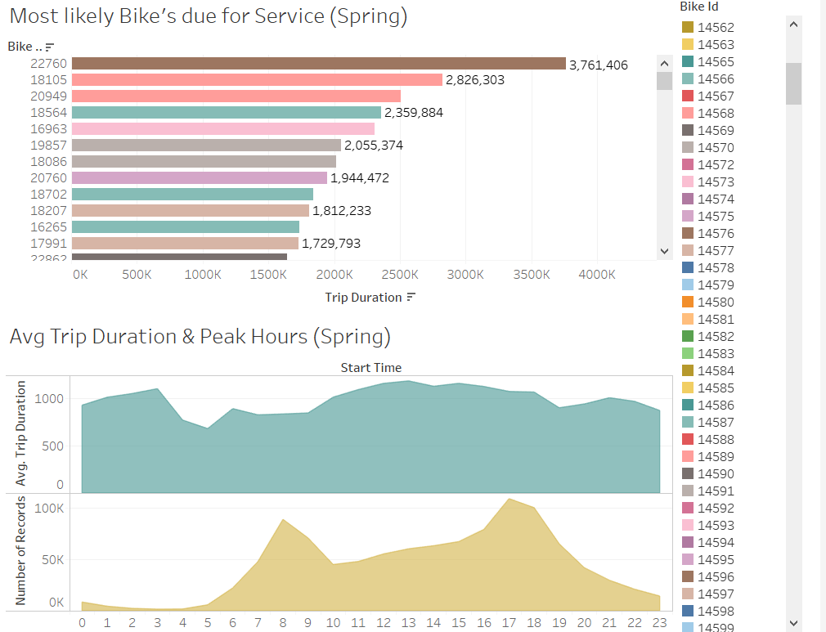

Phenomenon 3:

The most popular stations to start and end also coincides with being the most populated areas within the city limits. The map of the coordinates of the start/end points supports this theory. Added the population layer to confirm the findings as well.